Correo Hofstad
Transportation Security Administration
Job announcement 12719962-SEA-FT-PT
Transportation Officer (TSO) Cover Letter
04/18/2025

The Path to Excellence: Correo Hofstad's Journey Toward Becoming a Transportation Security Officer at SeaTac Airport

Introduction: A Quest for Safety and Security
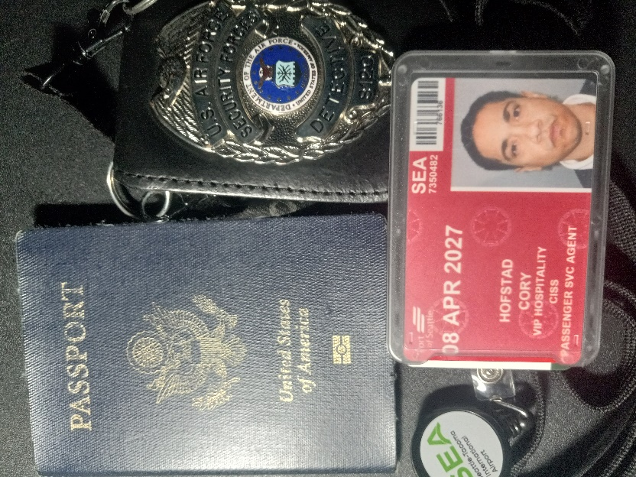
In today's world, the importance of airport security cannot be overstated. As global travel resumes and complexities arise, organizations like the Transportation Security Administration (TSA) play a pivotal role in ensuring passenger safety. One individual passionate about this mission is Correo Hofstad, who currently serves as a full-time Access Control / Divestiture Agent with VIP Hospitality at SeaTac Airport. Correo's dedication to maintaining secure environments and facilitating efficient travel experiences has led him to apply for a Transportation Security Officer position.
Correo Hofstad's experience and commitment to excellence make him a strong candidate for this critical role. His journey reflects a deep understanding of security procedures, a focus on customer service, and a desire to contribute meaningfully to the safety of all who travel. This blog post will explore the various facets of Correo's professional endeavors and underscore the qualifications he brings to the TSA and SeaTac Airport.
The Role of a Transportation Security Officer
Transportation Security Officers (TSOs) play a vital role in the safety and security of air travel. They are the frontline defenders responsible for monitoring passengers and their belongings, ensuring compliance with TSA regulations, and embarking on processes to mitigate potential threats. In pursuing this role, Correo Hofstad recognizes the critical responsibilities that TSOs uphold at airports like SeaTac.
To excel as a TSO, one must embody vigilance, a keen sense of observation, and an unwavering commitment to security protocols. Correo understands these demands and is equipped with the skills necessary to thrive in such a fast-paced, demanding environment, embodying the dedication required to maintain a secure atmosphere for passengers and airport staff.
Current Role at SeaTac Airport
Currently, Correo Hofstad fulfills his duties as an Access Control / Divestiture Agent with VIP Hospitality at SeaTac Airport. His role involves guiding passengers through the security checkpoints and ensuring their belongings are appropriately prepared for screening. He collaborates closely with TSA Officers, solidifying their collective mission of passenger safety and efficient airport operations.
As a Divestiture Agent, Correo provides essential guidance in divesting, helping travelers navigate the complexities of security screening. He ensures compliance with TSA regulations and enhances the passenger experience by minimizing delays. This experience favors Correo for the Transportation Security Officer role, where efficiency and compliance remain paramount.

EXIT Monitoring
One of Correo's key responsibilities at SeaTac Airport involves EXIT monitoring. This aspect of his role is crucial for maintaining the integrity of the Sterile Area by preventing unauthorized access. Correo diligently monitors individuals exiting this space and ensures that security protocols are followed rigorously.
By verifying the credentials of individuals attempting to re-enter the Sterile Area, Correo adds an essential layer of security to the airport. He instantly reports any irregularities or unauthorized access, supporting TSA's commitment to a secure airport environment. This proactive approach demonstrates Correo's alignment with TSA's objectives, positioning him as an exemplary candidate for the Transportation Security Officer position.

Engaging Passengers at Checkpoints
In his current role, Correo Hofstad actively engages with passengers at security checkpoints, employing effective communication skills to guide them through the divesting process. He provides clear instructions on preparing their belongings for screening, ensuring travelers understand the requirements thoroughly.
These interactions emphasize Correo's communication prowess and highlight his customer-focused approach. By creating a positive and informative atmosphere at checkpoints, he reduces travelers' stress and enhances their overall experience at the airport. This direct interaction with passengers underscores the importance of customer service in the security domain, a skill that will serve him well as a Transportation Security Officer.

Preparing for Airport Screening
Preparing for airport screening can often be overwhelming for passengers unfamiliar with TSA regulations. Correo Hofstad addresses these challenges head-on by providing detailed guidance on the necessary divestiture requirements. He ensures travelers know what to do, from removing shoes to placing large electronics and liquids separately.
By offering such comprehensive instructions, Correo minimizes the chances of alarms and delays, allowing for smoother throughput at checkpoints. His experience as a Divestiture Agent has equipped him with knowledge of TSA procedures, enhancing his ability to enforce compliance as a future Transportation Security Officer.
The Importance of Attention to Detail
Attention to detail is a hallmark of effective security personnel, and Correo Hofstad embodies this quality. Whether monitoring Exit Lanes or assisting passengers in divesting, he demonstrates a meticulous approach to his responsibilities. This attention to detail ensures that he adheres to TSA guidelines, contributing to the overall security of SeaTac Airport.
Correo's keen eye for detail will be invaluable in pursuing the transportation security officer role. He understands that the smallest oversight can lead to significant security breaches, thus prioritizing thoroughness in every aspect of his work. His dedication to detail exemplifies his readiness for the challenges in the TSA.
Essential Qualifications and Requirements
Correo Hofstad's qualifications align seamlessly with the requirements outlined for the Transportation Security Officer position. His strong communication skills allow him to convey instructions clearly and effectively as he interacts with passengers and colleagues. Additionally, his ability to maintain composure in high-stress environments showcases his professionalism and grounding in security best practices.
Prior experience in security and customer service complements Correo's qualifications, establishing a foundation of knowledge that supports TSA's objectives. His background equips him with the insights needed to navigate the dynamic environment of airport security, instilling confidence in his capabilities as a potential TSA Officer.
The Work Environment at SeaTac Airport
Working at SeaTac Airport provides unique challenges and opportunities for personal and professional growth. Correo Hofstad's daily interactions in this bustling airport environment foster a culture of vigilance and teamwork. He is accustomed to standing for extended periods while interacting with a diverse range of passengers, all of which are integral components of working in airport security.
The fast-paced nature of airport operations requires personnel to adapt quickly to changing circumstances. Correo has proven himself equipped to thrive in this setting, maintaining high standards of security while fostering a positive atmosphere for travelers. Such adaptability is a key trait that will transfer well to the role of a Transportation Security Officer.
Commitment to Exceptional Service
In every role, Correo Hofstad demonstrates a clear commitment to exceptional service. He understands that airport security transcends mere compliance with procedures; it embodies an overarching goal of safeguarding public trust in the air travel system. By providing passengers guidance, support, and empathy, he makes their journey through security less daunting.
This focus on service excellence resonates with the TSA's mission to provide top-notch security while ensuring a seamless travel experience. Correo's dedication to these ideals positions him favorably within the context of his job application for the TSO position at SeaTac Airport.
Future Aspirations in Transportation Security
With his sights set on becoming a Transportation Security Officer, Correo Hofstad is poised to take his career to the next level. His dedication to enhancing safety and compliance has prepared him for this opportunity. As he navigates the job application process, Correo remains optimistic about the future and his potential impact in a TSO role.
Transitioning into this position would allow Correo to further contribute to the security of SeaTac Airport while optimizing the travel experience for hundreds of thousands of passengers. His journey exemplifies a commitment to continuous improvement, showcasing how dedicated individuals can make a significant difference in airport safety and efficiency.
A Strong Candidate for the TSA
Ultimately, Correo Hofstad's journey toward applying for the Transportation Security Officer position reflects his substantial experience, unwavering commitment, and passion for security. His current work as an Access Control / Divestiture Agent at SeaTac Airport has prepared him well for this next chapter. By adhering to TSA guidelines and enhancing passenger experience, Correo embodies the values the TSA seeks in its personnel.
As he moves forward in the job application process, Correo's aspirations align seamlessly with the mission of the Transportation Security Administration. His dedication to maintaining a secure and efficient airport environment positions him not just as a candidate but as a vital asset to the ongoing mission of ensuring travelers' safety and air travel integrity.

Dr. Correo “Cory” Andrew Hofstad Med Sci. Educ, PO, ND, DO, PharmD, OEM, GPM, Psych, MD, JSD, JD, SEP, MPH, PhD, MBA/COGS, MLSCM, MDiv

1 (206) 837-5051
Cory.hofstad@seattlecolleges.edu

